**Device Degradation Measurements - Standard Operating Procedure**

Revised 3 January 2022 by Wiley Dunlap-Shohl

**A. Instrument Configuration**

1. Make sure the big box is set up and air tight (depending on the desired atmosphere).

2. Attach the Olympus 5X or 20X objective to the nosepiece of the microscope using the PLE352 parfocal length extender. The 5X is most suitable for typical device sizes (~3 mm field of view).

3. Place the motorized stage on the circular microscope platform and secure the set screw using a 5/64” hex wrench.

4. Attach alligator clip leads to the positive and negative terminals of the bottom Keithley sourcemeter (i.e., not the one used with the transmittance photodiode). If switching from the typical photoconductivity measurement configuration, make sure to bypass the resistor across the terminals of the lock-in amplifier. (It’s safest to bypass the lock-in amp entirely.)

5. Make sure that Python and MicroManager are running on the control computer.

6. Verify that the filter cube motor is engaged with the wheel and responsive to the Python commands (motor.run(1): switch to bright field; motor.run(2): switch to dark field; motor.run(3) : switch to PL;). Make any adjustments to the motor position so that it switches reliably on command.

6A. If the motor is not responsive, run the motor_update.py script and then motor = Stepper_motor()in the command line.

7. Bring up the “PL_JV_electronic_control_script_modular.py” script and make any changes to the software configuration. Most of the time this will only involve changing the path that specifies the folder where you want to save the data. Less frequently, you may wish to change the measurement modes by changing the fields in the meas_to_make dictionary (by default, all are True).

8. In MicroManager, switch the binning to 4x4 if not already set.

9. In the Tools → Script Panel dropdown menu in MicroManager, open the “Stoddard_DF_PLVA_JV_device_modular.bsh” script. As in Step 7, change the path to the folder where you want to save the data, and change the basename to the serial number of the device. If using dark field, make sure the dark_field variable is set to True.

**B. Mounting a Device**

1. Take the aluminum heating stage and place it upside down, exposing the device pocket, with the thermocouple leads to the left.

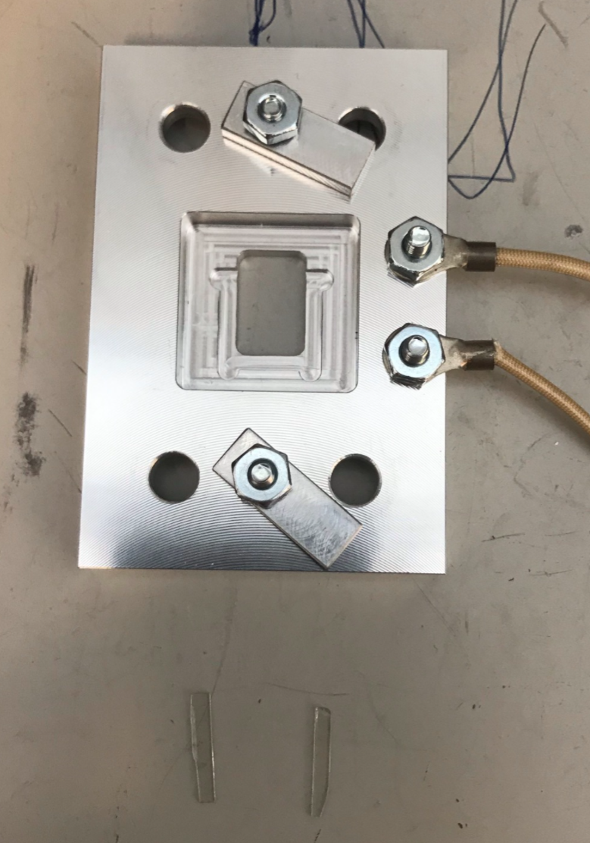

2. Place the two glass shims on either side of the pocket.

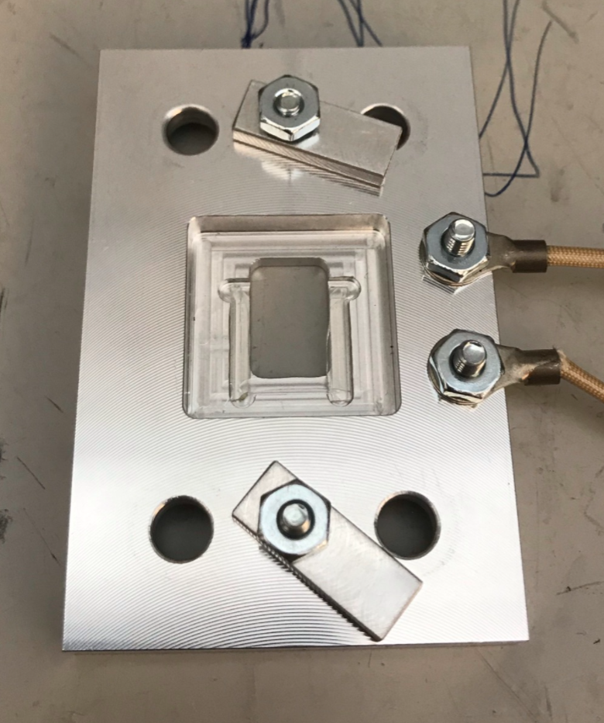

3. Place the device in the pocket so that it rests on the shims as shown below.

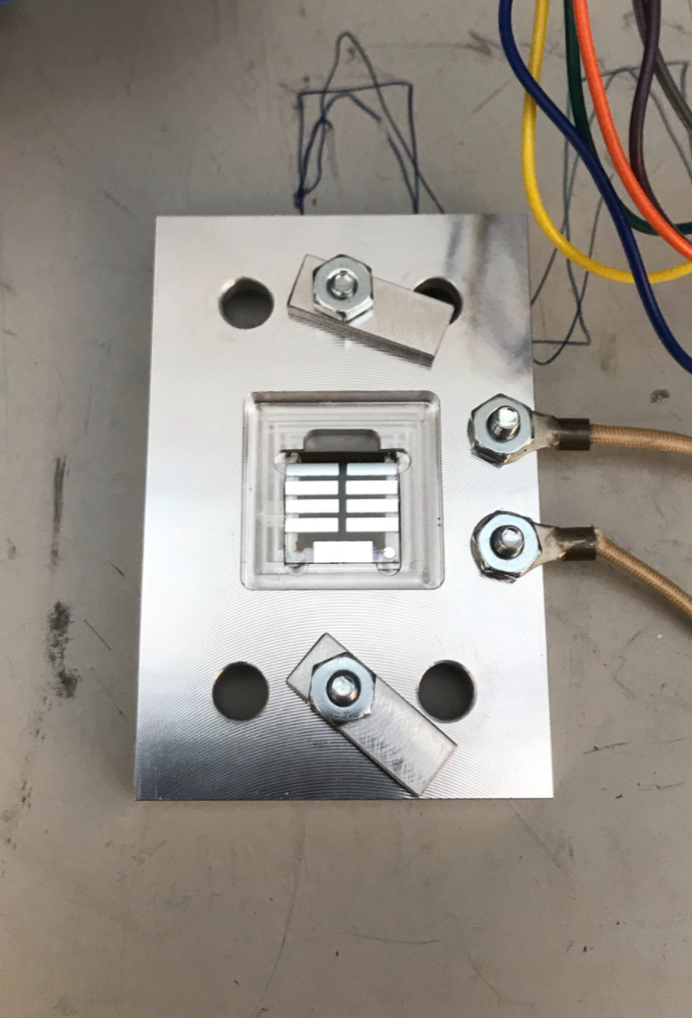

4. Place the boron nitride pin holder on the device such that the pins make contact with the nine electrodes on the device. The wires should extend in the same direction as the thermocouples. *Be very careful when handling this part; the pin holder is fragile, and so are the solder connections joining the wires to the pins.*

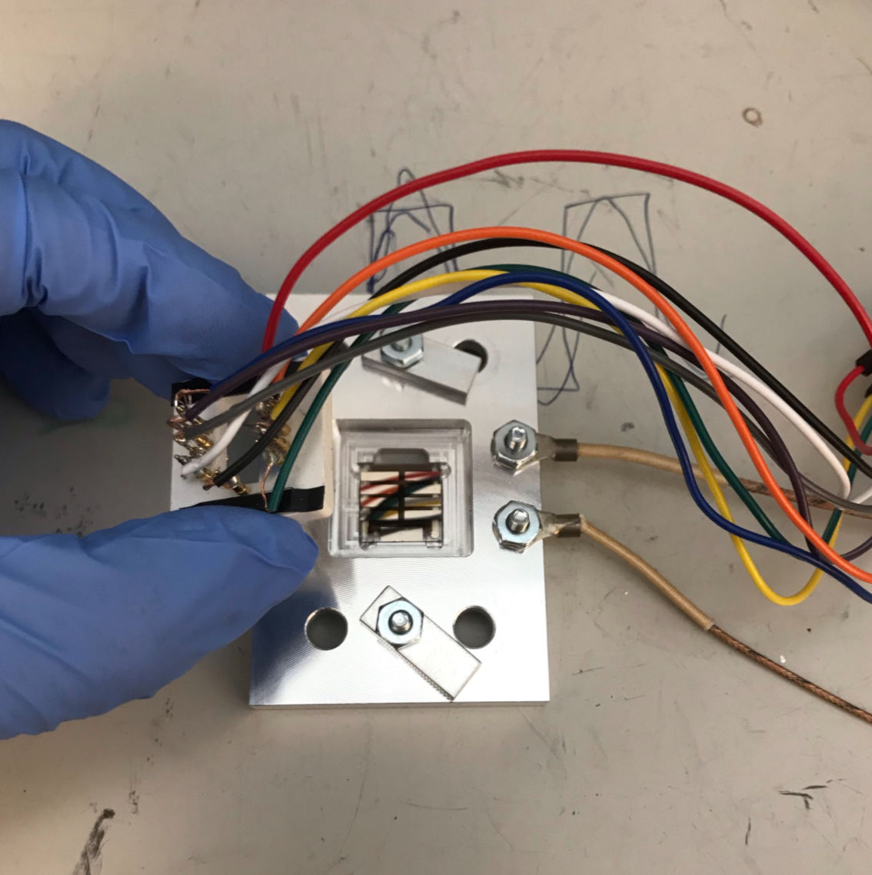

5. Secure the pin holder in place using the two aluminum clamps. Do not tighten them all the way down; only enough for the springs in the pins to hold everything in place.

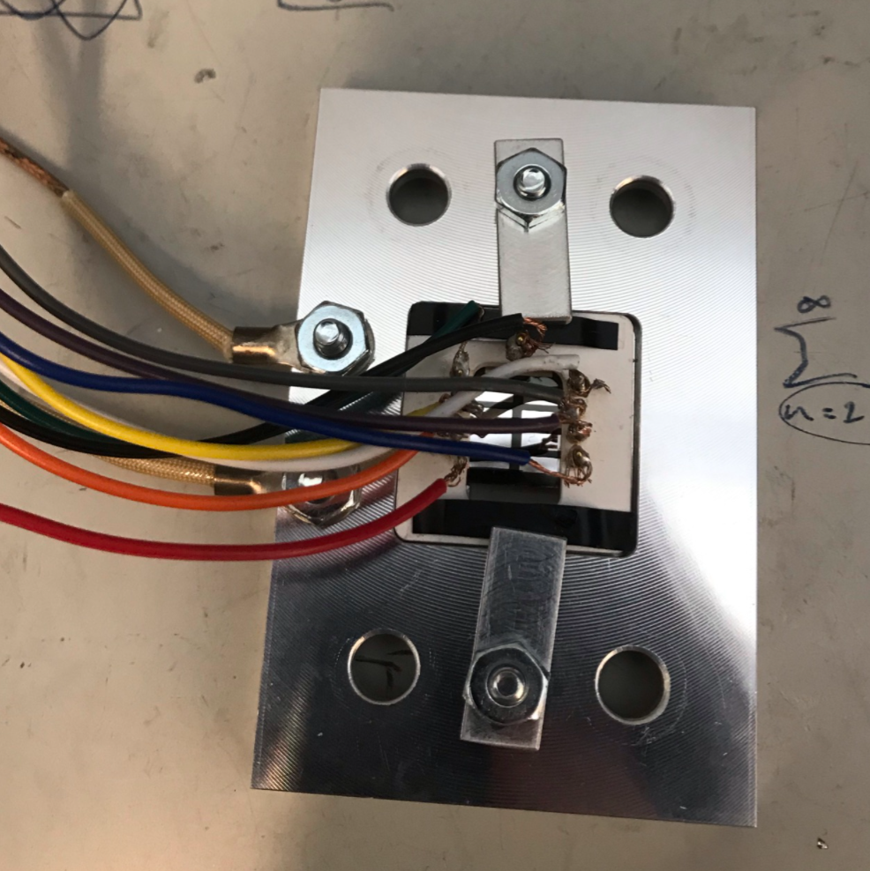

6. Carefully transfer the device stage to the mounting plate. Support the wires to minimize stress on the solder connections.

7. Slide the cartridge heaters into their channels in the device stage.

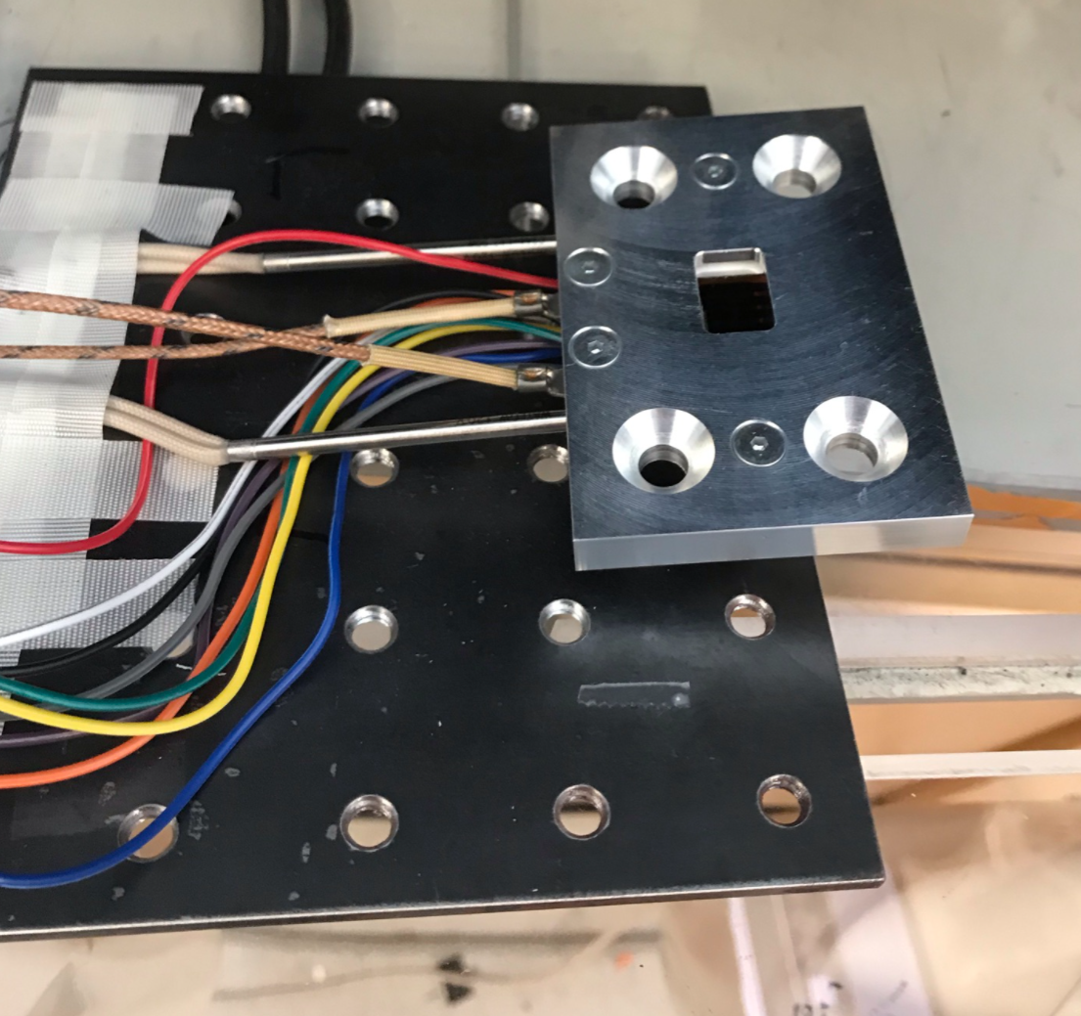

8. Place the four aluminum standoffs underneath the mounting holes on the device stage, and secure the stage to the plate using flathead screws (5/32” hex wrench).

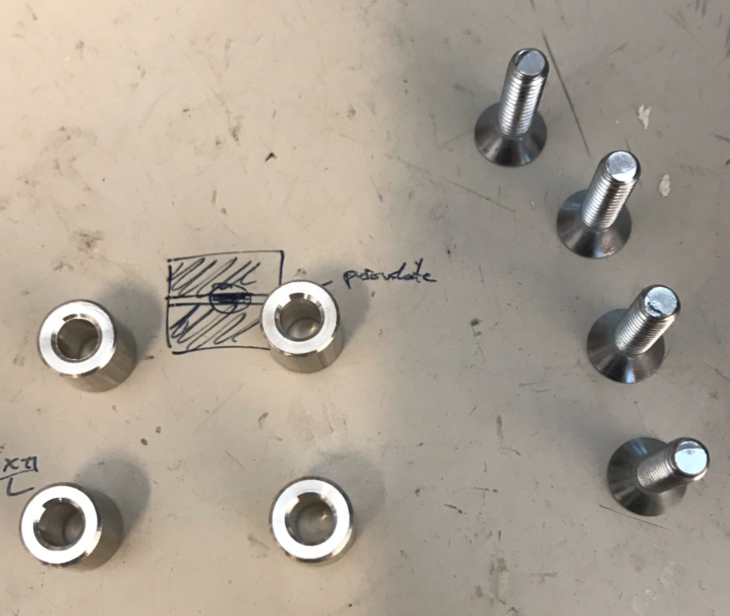

9. Place a few drops of isopropanol on the corner of a tissue, and gently wipe the exposed glass face of the device to remove dust. (This minimizes out-of-focus aberrations in the PL and DF images.)

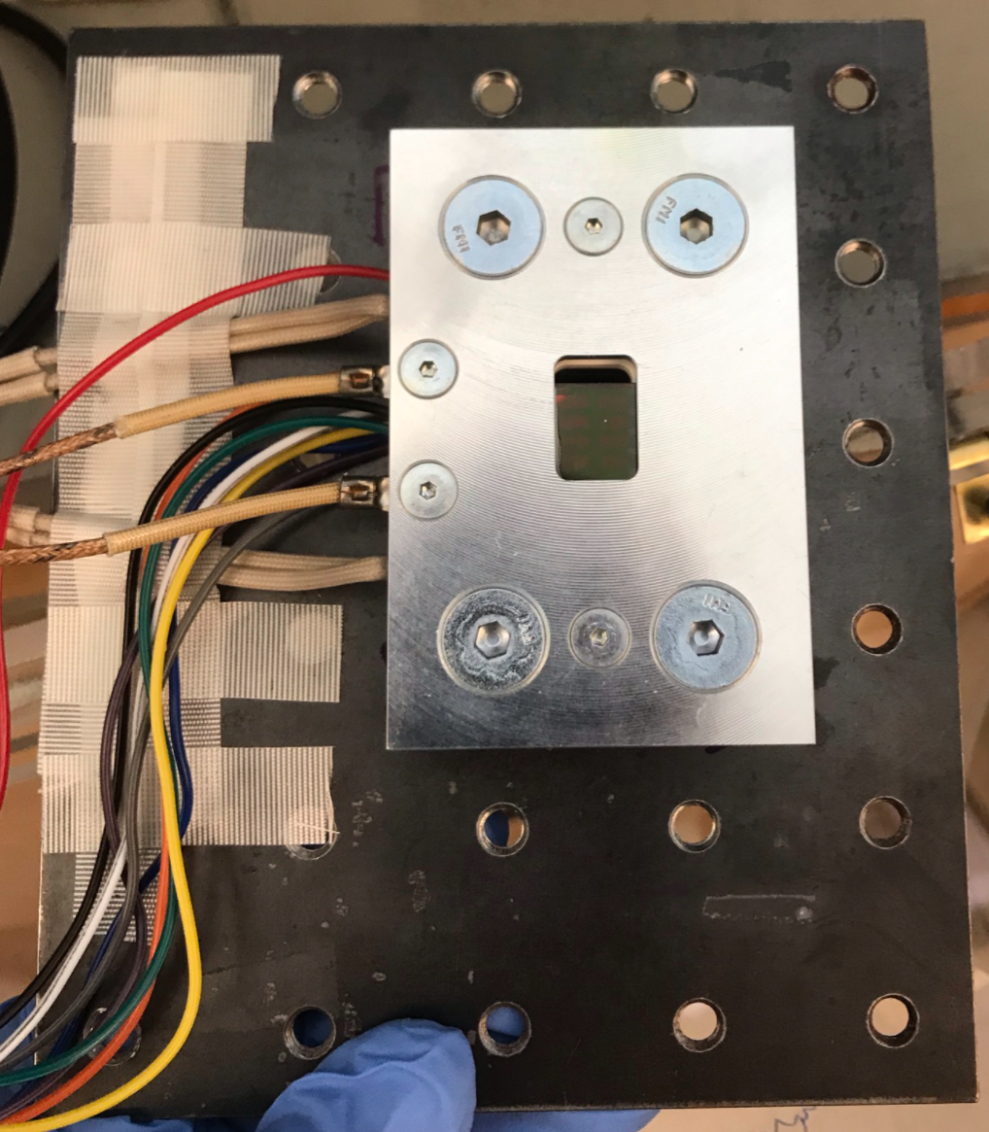

10. Place the mounting plate on the stage.

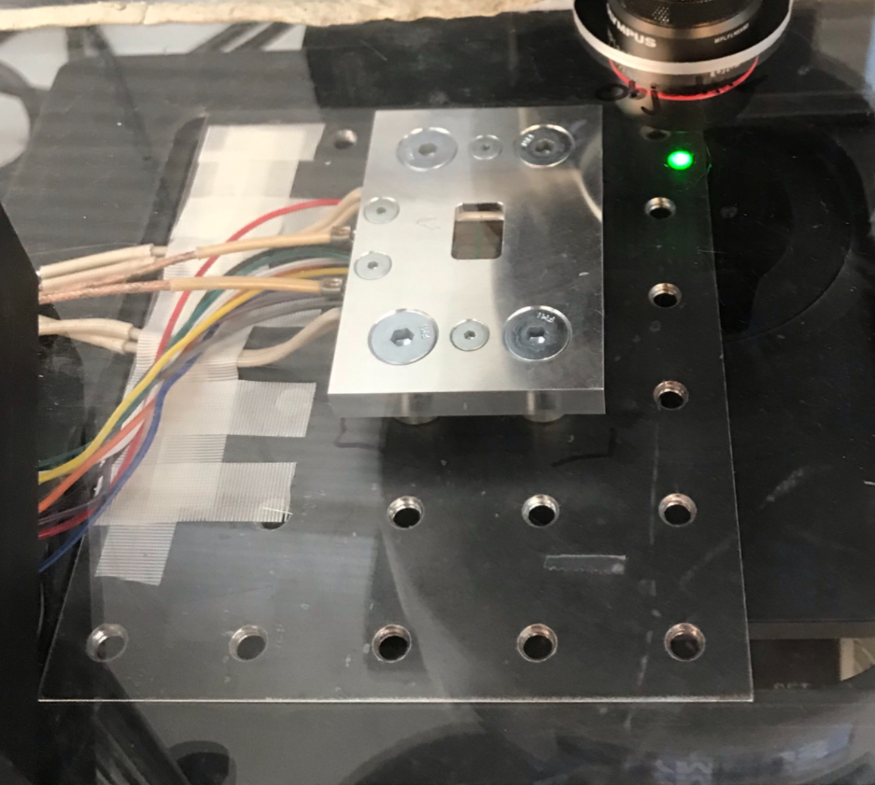

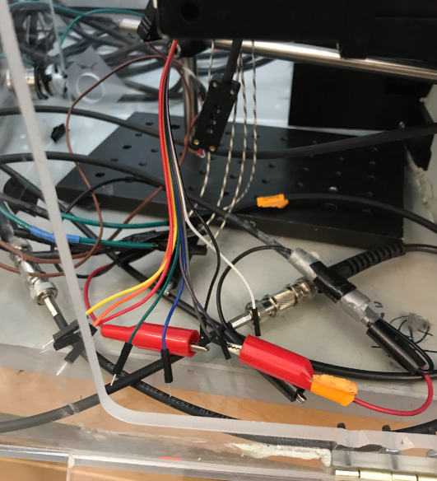11. Connect the two thermocouples to the brown leads in the box, and connect the positive and negative leads to the red alligator clips. Always use the black lead, which connects to the counterelectrode on the device. Which of the colored leads to use depends on which device you intend to measure. Following the RTT convention:

1 – white

2 – grey

3 – purple

4 – blue

5 – green

6 – yellow

7 – orange

8 – red

12. Verify that the polarity of the leads is correct by measuring the short-circuit current using the Keithley sourcemeter. The photocurrent under ambient light is typically on the order of μA and should be ***negative*** – if it isn’t, exchange the leads connected to the alligator clips.

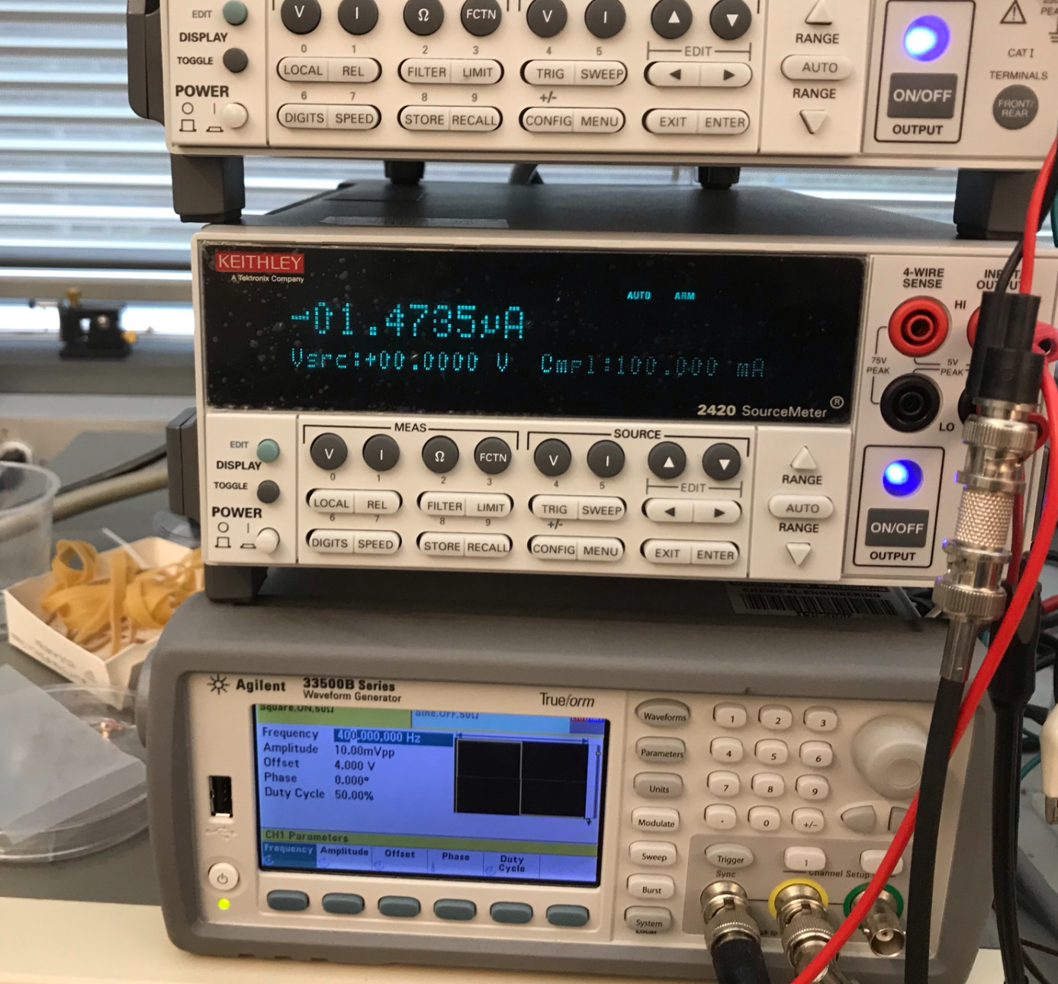

13. If using the temperature control stage, verify that the device heaters are plugged in and the **film stage heaters are unplugged**. If the film stage heaters are plugged in, they will also heat up and could damage anything they contact.

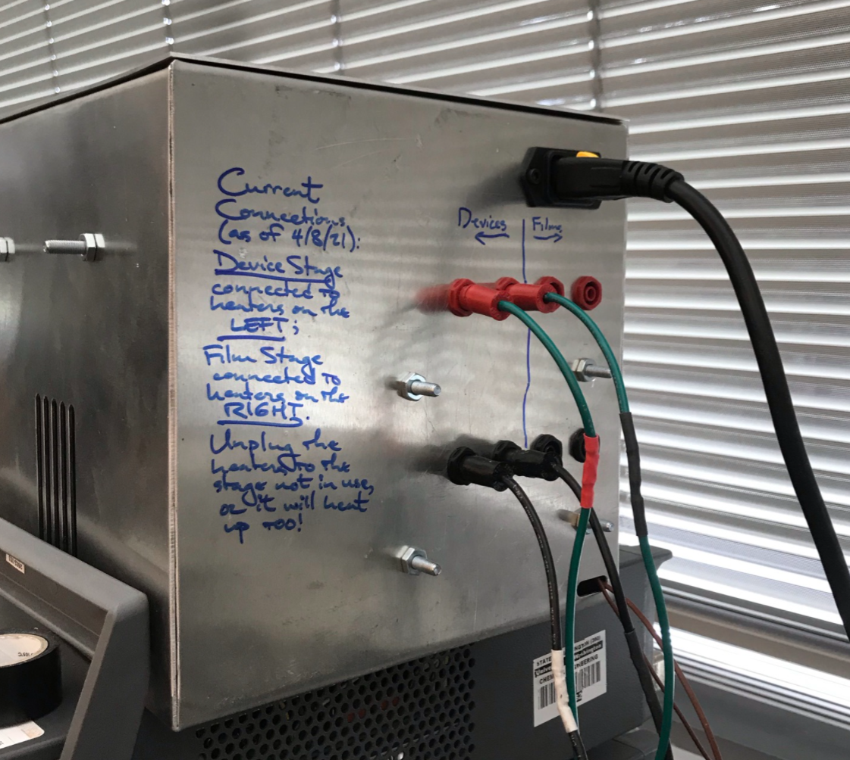

13. If using the temperature control stage, verify that the device heaters are plugged in and the **film stage heaters are unplugged**. If the film stage heaters are plugged in, they will also heat up and could damage anything they contact.

14. Turn on the heater and set the controller to the desired set point.

15. Set the microscope to PL mode, with ND25 filter engaged and the Lumencor light source at the 143/255 power setting (this corresponds to 1 sun).

16. Drive the stage so the device is centered under the beam.

17. Focus the PL image – it may be easier to do this in open- rather than short-circuit conditions. Use the “Stoddard_getPos.bsh” program in MicroManager to record the position (only the Z coordinate really matters).

18. Make fine adjustments as necessary to maximize the short-circuit current.

19. Set the microscope to dark field mode, refocus the image, and use “Stoddard_getPos.bsh” to record the coordinates. This step can be tricky, and it can be easy to mistake focal planes for the one containing the device. A useful rule of thumb is that you will have to raise the stage by 500-1000 μm above the PL focal plane to get the dark field image in focus when using the 5X objective.

20. Enter the PL and DF focal positions in the MicroManager script as the Z_Pos_PL and Z_Pos_DF variables.

21. Return the microscope to PL mode and switch off the light (light.off() in Python command line).

22. Seal the box and turn the humidifier on to the “MIN” setting, if it is not there already.

23. Double check that the temperature and humidity settings are correct, and that the Python and MicroManager control scripts are configured as desired and consistently with one another.

24. When you are certain that everything is ready, run the Python script cellwise (using Shift+Enter). Immediately after starting the Python script, click “Run” in MicroManager.

25. Verify that the scripts are running correctly.

**Checklist Before Starting the Experiment**

* “Sample Info” metadata file created
* “Experiment Info” metadata file created
* Gradient is at the correct temperature
* Correct probe and soak light intensity settings are set
* MicroManager is off
* Filter cube set to position 3
* Box gas line is connected and purging (if used)
* Gas cylinder has adequate pressure until the next time someone will be in lab to check it
* Humidifier is operational and set to the desired humidity level
* Gas purge and humidifier are working to keep RH at the correct level
* Device is hooked up with the correct polarity and behaving normally
* Z values for PL and dark field in the Python control program are correct